Chapter 7

Introduction to React
- React is an open-source JavaScript library developed by Facebook.
- Used to build interactive and fast web applications.
- React mainly handles the View layer in MVC architecture.
- Popular applications using React:
  - Facebook
  - Instagram
  - Netflix
  - WhatsApp Web

Advantages of React
- Component-based architecture
- Reusable code
- Faster rendering
- Easy maintenance
- Declarative programming
- Efficient DOM updates

Virtual DOM
Virtual DOM is a lightweight copy of the Real DOM.

Working:
- React creates Virtual DOM
- Compares old and new Virtual DOM
- Updates only changed elements in Real DOM

Advantages:
- Faster UI updates
- Better performance
- Smooth rendering

SPA (Single Page Application)
SPA loads a single page and updates content without full page reload.

Features:
- Faster navigation
- Better user experience
- Uses react-router-dom
- Uses <Link> instead of <a> tag

Installation & Setup using Vite

Check Node.js
node -v
npm -v

Create React App using Vite

1. Create Vite Project
npm create vite@latest
Starts the Vite setup wizard.

2. Enter Project Name
Example:
myapp
Creates a folder named myapp.
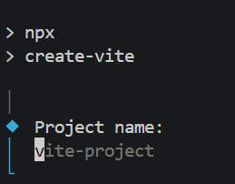

3. Select Framework
Choose:
React
Used to create a React application.
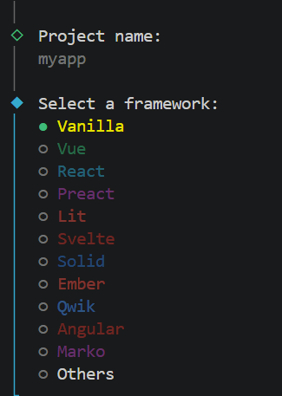

4. Select Variant
Choose:
JavaScript
- Easy for beginners
- Most tutorials use this
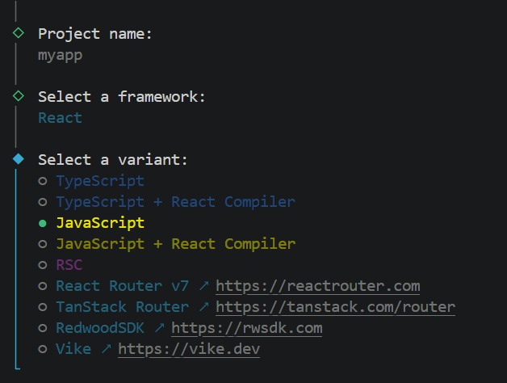

JavaScript + React Compiler is an advanced optimized version.
5.Vite asks to start
Install with npm and start now?
If you choose:
Yes
Vite automatically runs:
npm install
npm run dev
So the development server starts automatically.

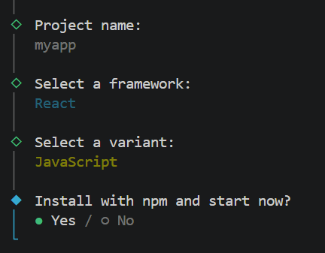

6. Open in Browser
http://localhost:5173/
Default Vite development URL.

If port 5173 is already in use, Vite automatically uses another port like:
5174
5175
Example:
Port 5173 is in use, trying another one...

Shortcut Command
npm create vite@latest myapp -- --template react
Creates a React project directly without asking questions.
Part | Meaning
Npm | Node package manager
Create | Create a new project
vite@latest | Use latest Vite
Myapp | Project folder name
-- | Pass options to Vite
--template react | Create a React project

Useful Vite Commands

Install and Start Project
cd project-name
npm install
npm run dev
- npm install → installs packages
- npm run dev → starts Vite server

Run on Different Port
npm run dev -- --port 3000

Stop Server
Ctrl + C

Build Project
npm run build
Creates production files.

Preview Build
npm run preview
Preview production version locally.

Folder Structure
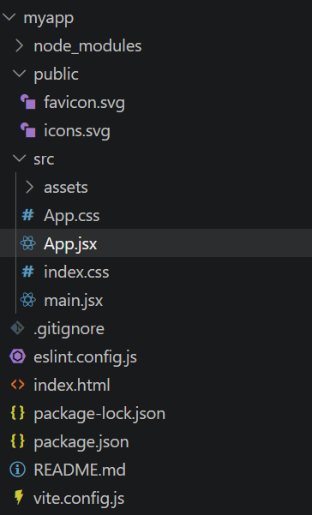
File / Folder | What it Contains | Purpose / Use | Important Notes
node_modules/ | All installed npm packages | React, Vite and other libraries are stored here | Created automatically after npm install. Very large folder. Never edit manually.
public/ | Static files | Stores files that should be directly accessible in browser | Files are not processed by Vite. Used for favicon, PDFs, static images, etc.
src/ | Main React code | Contains all components, CSS, logic and pages | Most project development happens here.
src/assets/ | Images, icons, fonts, videos | Used to store component-related media files | Best place for images used inside React components.
src/App.jsx | Main React component | First component displayed in browser | Main UI design is usually written here.
src/main.jsx | Entry point file | Starts React app and connects with index.html | Flow: index.html → main.jsx → App.jsx
src/App.css | CSS for App component | Styles only App component UI | Used for component-specific styling.
src/index.css | Global CSS | Applies styles to whole application | Used for body styling, fonts, reset CSS, etc.
.gitignore | Ignored files list | Prevents unnecessary files from uploading to GitHub | Usually ignores node_modules, build files, environment files.
eslint.config.js | ESLint rules | Checks coding mistakes and code quality | Helps maintain clean and error-free code.
index.html | Main HTML page | Base HTML file loaded in browser | Contains <div id="root"></div> where React app renders.
package.json | Project configuration | Stores dependencies, scripts and project details | Contains commands like npm run dev, installed package names, versions.
package-lock.json | Exact dependency versions | Locks package versions for consistency | Automatically generated by npm.
README.md | Documentation file | Contains setup instructions and project notes | Written in Markdown format.
vite.config.js | Vite configuration | Used to customize Vite settings | Used for custom port, aliases, plugins, etc.

Rendering Flow
index.html → main.jsx → App.jsx
- index.html contains root div
- main.jsx connects React with browser
- App.jsx displays actual UI

index.html
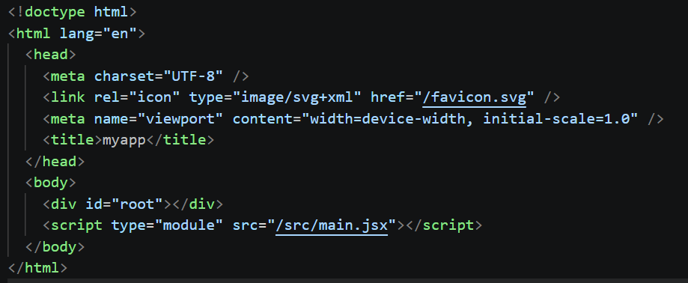
It is the main HTML file of the React application.
When the application starts, this file loads first in the browser.
Code | Purpose | Explanation
<!doctype html> | Defines HTML version | Tells browser to use HTML5.
<html lang="en"> | Root HTML tag | lang="en" specifies webpage language as English.
<head> | Metadata section | Contains title, favicon, charset and other settings.
<meta charset="UTF-8" /> | Character encoding | Supports special characters, symbols and multiple languages.
<link rel="icon" type="image/svg+xml" href="/favicon.svg" /> | Website icon | Sets favicon shown in browser tab. File comes from public/ folder.
<meta name="viewport" content="width=device-width, initial-scale=1.0" /> | Responsive design | Makes website responsive on mobile, tablet and desktop screens.
<title>myapp</title> | Browser tab title | Displays myapp on browser tab.
<body> | Visible webpage section | Contains content displayed in browser.
<div id="root"></div> | Root container | React app renders inside this div.
<script type="module" src="/src/main.jsx"></script> | Loads React app | Starts application from main.jsx. type="module" enables modern JavaScript modules.

main.jsx
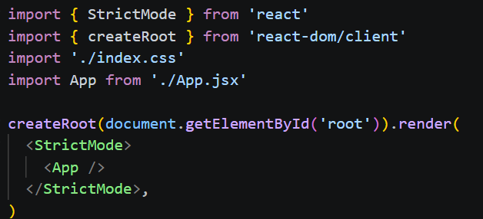
Code | Purpose | Explanation
import { StrictMode } from 'react' | Imports StrictMode | Helps detect warnings and potential problems during development.
import { createRoot } from 'react-dom/client' | Imports createRoot | Used to render React app into browser DOM.
import './index.css' | Imports global CSS | Applies CSS styles to entire application.
import App from './App.jsx' | Imports App component | Loads the main React component.
document.getElementById('root') | Selects root div | Finds <div id="root"></div> from index.html.
createRoot(...) | Creates React root | Initializes React rendering system.
.render() | Renders React app | Displays React components in browser.
<StrictMode> | Development checking tool | Shows warnings for unsafe or outdated React code.
<App /> | Main component | Main UI component rendered inside root div.

App.jsx
Code | Purpose | Explanation
import { useState } from 'react' | Imports Hook | useState is used to create and manage state in React.
import reactLogo from './assets/react.svg' | Imports image | Loads React logo from assets folder.
import viteLogo from './assets/vite.svg' | Imports image | Loads Vite logo from assets folder.
import heroImg from './assets/hero.png' | Imports image | Loads hero image from assets folder.
import './App.css' | Imports CSS | Applies styles for App.jsx.
function App() | React component | Main functional component of application.
const [count, setCount] = useState(0) | State creation | Creates state variable count with initial value 0.
Count | State variable | Stores current counter value.
setCount() | State update function | Updates count value.
return() | Returns JSX | Displays UI elements in browser.
<> </> | Fragment | Groups multiple elements without adding extra HTML tags.
<section id="center"> | Section container | Main content section of page.
<img src={heroImg} /> | Displays image | Shows imported image in browser.
className="hero" | CSS class | Applies CSS styling. React uses className instead of class.
<h1>Get started</h1> | Heading | Displays main heading.
<code> | Code formatting | Displays text in code style.
<button> | Button element | Creates clickable button.
onClick={() => setCount(...)} | Click event | Runs function when button is clicked.
setCount((count) => count + 1) | Updates state | Increases counter value by 1.
Count is {count} | Dynamic value | Displays updated counter value using JSX expression.
<a href="https://vite.dev/"> | Hyperlink | Opens Vite documentation website.
target="_blank" | Open in new tab | Opens link in new browser tab.
<svg> | SVG icon | Displays vector icons.
export default App | Export component | Makes App component available for use in main.jsx.

Note:
React components can be created using both .js and .jsx extensions.
.jsx is recommended for component files because it clearly indicates the file contains JSX (React UI code).
Extension | Common Usage
.jsx | React components
.js | JavaScript logic/helper files

Why Component Names Start with Capital Letters?
- React uses capitalization to identify components.
- Capital letters help React distinguish components from normal HTML elements.
- Bottom of Form

It is recommended to create component file names starting with capital letters to avoid confusion.
Name | React Treats It As
Header | React component
header | HTML tag
Correct:
function Header() {}
Wrong:
function header() {}

Understanding package.json
package.json is the main configuration file of a React project.
It contains:
- project information
- dependencies/packages
- scripts/commands
- package versions
Example:
{
"name": "myapp",
"version": "0.0.0",
"scripts": {
"dev": "vite",
"build": "vite build"
}
}

Important Fields in package.json
Field | Purpose
name | Project name
version | Project version
scripts | Commands like npm run dev
dependencies | Installed packages
devDependencies | Development packages

React Rendering
React renders UI using:
- createRoot()
- render()

Example
import { createRoot } from 'react-dom/client'
import App from './App.jsx'
createRoot(document.getElementById('root')).render(
<App />
)

React Components
- A React component is a JavaScript function that returns JSX (UI code).
- Components are reusable UI elements in a React application.
- Every part of UI in React is treated as a component.
- Component names should start with a capital letter.
- Components return JSX markup.

Default Component: App.jsx
When a React project is created using Vite, App.jsx is created by default.
It is the main component rendered in browser.

Rendering Flow
index.html → main.jsx → App.jsx

Replace Default Code in App.jsx
function App() {
return (
<div>
<h1>Hello World!</h1>
</div>
)
}
export default App

Code | Purpose
function App() | Creates React component
return() | Returns JSX/UI
<h1>Hello World!</h1> | Displays heading in browser
export default App | Exports component

Create Your Own Component
Instead of modifying App.jsx, you can create your own component file.
Example:
src/Myapp.jsx
function Myapp() {
return (
<div>
<h1>Hello World!</h1>
</div>
)
}
export default Myapp

Import Component in main.jsx
Replace:
import App from './App.jsx'
with:
import Myapp from './Myapp.jsx'

Replace:
<App />
with:
<Myapp />

Updated main.jsx
import { StrictMode } from 'react'
import { createRoot } from 'react-dom/client'
import './index.css'
import Myapp from './Myapp.jsx'
createRoot(document.getElementById('root')).render(
<StrictMode>
<Myapp />
</StrictMode>,
)
Now Myapp.jsx will render in browser instead of App.jsx.

JSX (JavaScript XML)
- JSX is a syntax extension of JavaScript used in React.
- It allows writing HTML-like code inside JavaScript.
- JSX makes UI code easier to read and write.
- React components return JSX to display UI in browser.
- JSX looks like HTML but follows stricter rules.

Example of JSX
function App() {
return <h1>Hello React</h1>
}

JSX Rules

1. Return Single Root Element
A component must return only one parent element.

Wrong JSX
function App() {
return (
<h1>Hello</h1>
<p>React</p>
)
}

Error
Adjacent JSX elements must be wrapped in an enclosing tag

Correct JSX
function App() {
return (
<div>
<h1>Hello</h1>
<p>React</p>
</div>
)
}

Fragment
Instead of <div>, we can use Fragment:
<>
<h1>Hello</h1>
<p>React</p>
</>

Advantage
- Avoids unnecessary extra HTML tags.

2. Close All Tags
All JSX tags must be properly closed.

Wrong
<img src="logo.png" >
<li>Apple
<input type="submit">

Error
JSX syntax error

Correct
<img src="logo.png" />
<li>Apple</li>
<input type="submit" />

3. Use camelCase Attributes
JSX attributes use camelCase because JSX converts into JavaScript objects.
HTML | JSX | Reason
class | className | class is reserved keyword in JavaScript
onclick | onClick | JSX uses camelCase for events
onchange | onChange | JSX uses camelCase
readonly | readOnly | JSX uses camelCase

Wrong
<h1 class="title">

Correct
<h1 className="title">

4. Passing JavaScript Expressions
Use {} to write JavaScript inside JSX.

Example
const name = "React"
<h1>{name}</h1>
Output:
React

JSX Expression | React Understands As | Output
<h1>{n}</h1> | Evaluate variable n | lju
<h1>"{n}"</h1> | Text " + value of n + text " | "lju"
<h1>{"{n}"}</h1> | JavaScript string "{n}" | {n}
<h1>{'{n}'}</h1> | JavaScript string '{n}' | {n}
<h1>{"n"}</h1> | JavaScript string "n" | n
<h1>{n + " test"}</h1> | JavaScript expression | lju test
<h1>{n.toUpperCase()}</h1> | Execute JS method | LJU
{5 + 5} | JavaScript math expression | 10
{[1,2,3]} | Array rendering | 123
{[1,2,3].join(",")} | Array join method | 1,2,3

5. JSX Styling
Inline CSS in JSX is written using JavaScript objects.

Correct Styling
<h1 style={{color:'red'}}>
Hello
</h1>

Styling Rules
Rule | Example
Use double curly braces | style={{}}
Use camelCase CSS | backgroundColor
CSS values are strings | "red"

Wrong
<h1 style="color:red">

Error
- JSX expects JavaScript object, not string.

6. JSX Comments
To write comments in React (JSX), we need to wrap them in curly braces.

Function comment() {
Return(
{/* this works */ }
)
}
The curly braces tell the JSX parser to parse the code inside as JavaScript, and not a string.

Since the contents inside are parsed as JavaScript, this enables us to also do multi-line or single-line comments:
function comment(){
return (
<>
{
/*
mult-line
test
*/
}
{
// single-line test
}
</>
)}
In the case of a single-line comment, You cannot have the ending bracket in the same line, because that will break everything. {// comments }-not valid

Example to understand jsx rules
Myapp.jsx
import "./My.css"
import img1 from "./assets/hero.png"

function Myapp() {
const name = "React"

return (
<>
{/* Inline CSS */}
<h1 style={{
color: "blue",
fontStyle: "italic",
fontSize: "25px"
}}>
Welcome to {name}
</h1>

{/* External CSS using className */}
<p className="para">
JSX allows writing HTML-like code inside JavaScript.
</p>

{/* Ordered List */}
<h3>List of Fruits</h3>
<ol type="A">
<li>Apple</li>
<li>Mango</li>
<li>Kiwi</li>
</ol>

{/* Image from assets folder */}
<img src={img1} alt="fruit" width="200" />

{/* Image from public folder */}
<img src="/favicon.svg" alt="logo" width="200" />

</>
)
}
export default Myapp
My.css
.para {
color: green;
font-size: 20px;
}
Import `Myapp.jsx` component in `Main.jsx` and replace `<App />` with `<Myapp />` to render the custom component in browser.
If you wish to see only your applied CSS, then comment out:
- index.css import from main.jsx
- App.css import from App.jsx
Example:
// import './index.css'
// import './App.css'

Map and Filter

Purpose of map() in React
- map() is used to loop through array elements.
- It helps to display data dynamically in React.
- It transforms each array item into JSX.
- It returns a new array.
- Mostly used for rendering lists.

Purpose of filter() in React
- filter() is used to remove unwanted data.
- It checks condition on every array element.
- It returns only matching elements.
- It creates a filtered array.
- Mostly used before map().
List and Keys
- key is used to give a unique identity to each element in a list.
- React uses key to identify which item is:
  - added
  - updated
  - deleted
- It helps React update the UI efficiently.
- key improves performance while rendering lists.
- It is mainly used with map() method.
- If lists do not include the key attribute, then it will give below warning. The warning says that each of the list items in our unordered list should have a unique key.

Warning: Each child in an array or iterator
should have a unique "key" prop

Keys are used in React to identify which items in the list are changed, updated, or deleted. In other words, we can say that keys are used to give an identity to the elements in the lists. It is recommended to use a string as a key that uniquely identifies the items in the list.
Use of key is given in below example. Without adding it you will get a warning as mentioned above.

Example

Create a React component that contains an array of student objects with:
- id
- name
- standard (std)

Perform the following tasks using filter() and map():
- Display only students whose standard is 5.
- Increase their standard by 1.
- Display student name and updated standard.

ProductList.jsx
function StudentList() {
const students = [
{
id: 1,
name: "abc",
std: 4
},
{
id: 2,
name: "xyz",
std: 6
},
{
id: 3,
name: "pqr",
std: 5
}
];

return (
<div>
<h1>Student Details</h1>

{
students
.filter((student) => student.std === 5)
.map((student) => (
<div key={student.id}>
<h2>Student Name : {student.name.toUpperCase()}</h2>
<h3>Updated Standard : {student.std + 1}</h3>

<hr />
</div>
))
}
</div>
);
}
export default StudentList;

React Props
- Props stand for Properties.
- Props are used to pass data from one component to another component.
- Props work similar to function arguments in JavaScript.
- Props help React components communicate with each other.
- Props are read-only (immutable), meaning we should not modify them directly.
Why We Use Props
Props are used to:
- pass data between components
- make components reusable
- display dynamic content
- communicate from parent component to child component

Syntax of Props
Passing Props
<ComponentName propertyName="value" />

Reading Props
function ComponentName(props) {
return <h1>{props.propertyName}</h1>
}

Example
Create a React application using props to display student details.
Requirements:
- Create a parent component Prop1.js.
- Pass the following data to child component Prop2.js using props:
  - student name
  - roll number
  - marks
- In child component:
  - display student details
  - increase marks by 1 and display updated marks
Understand the difference between:
marks={20} marks="22" from example

Step 1: Pass props to the component
Prop1.jsx
import Prop2 from "./Prop2";

function Prop1 () {
var n = "ABC";
return (
<div>
<Prop2 name={n} rollnum="101" marks={20} />
<Prop2 name="DEF" rollnum="102" marks={16} />
<Prop2 name="GHI" rollnum="103" marks="22" />
</div>
);
}
export default Prop1;

Step 2: Read props inside the component
Prop2.jsx
function Prop2(props){
return(
<div>
<ul>
<li>{props.name}</li>
<li>{props.rollnum}</li>
<li>{props.marks +1}</li>
</ul>
</div>
);
}
export default Prop2;

Output:
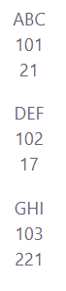
Difference Between "" and {}
Syntax | Type
"22" | String
{22} | Number / JavaScript value

Example
Create a React application using props to pass an object from one component to another component.
Requirements:
- Create a parent component Example1.js.
- Create an object named Details containing:
  - Student_name
  - University_name
- Pass the Details object to child component Example.js using props.
- In child component:
  - receive the object using props
  - display student name and university name in browser
Example1.jsx
import Example from "./Example";
function Example1 () {
const Details = {Student_name: "abc", University_name: "LJU"};
return (
<div>
<Example data ={ Details }/>
</div>
) }
export default Example1

Example.jsx
function Example(props) {
return(
<h2> My name is {props.data.Student_name}.
I am a student of { props.data.University_name } University !</h2>
) }
export default Example
Output:
My name is abc. I am a student of LJU University !
Example
Build a React app that displays a list of products using props.
- Create a ProductCard component to show product details like title, price, rating, and image.
- Use a ProductList component to store product data and display multiple ProductCard components using .map().

ProductList.jsx
import ProductCard from './ProductCard';
import img1 from "./img1.png"
import img2 from "./img2.png"

function ProductList() {
const products = [
{
title: "iPhone 17 Pro",
price: "99999",
rating: 4.8,
image: img1
},
{
title: "Samsung Galaxy S24",
price: "60000",
rating: 4.5,
image: img2
}
];

return (
<div>
<h1>Our Products</h1>
<ProductCard productList={products} />
</div>
);
}

export default ProductList;
ProductCard.jsx
function ProductCard(props) {
return (
<>
{
props.productList.map((product, index) => (
<div>
<img src={product.image} alt={product.title} width="100%" />
<h2>{product.title}</h2>
<p>Price: {product.price}</p>
<p>Rating: {product.rating}</p>
</div>
))
}
</>
);
}
export default ProductCard;

React Events
To handle events with React elements is very similar to handle events with DOM events. There are some syntax differences as below:
React events are named using camelCase, rather than lowercase as we used to do in HTML.
In HTML:
<button onclick="demofunction()">
LJ University
</button>

In React:
<button onClick = { demoFunction }>
LJ University
</button>

Another difference is that we cannot return false to prevent default behavior in React. We must call preventDefault explicitly.
preventDefault is used to prevent the default form behavior of submitting.

In HTML
<form onsubmit="console.log (' You clicked submit. '); return false">
<button type="submit">Submit</button>
</form>

In React
function Form () {
function handleSubmit (e) {
e.preventDefault ();
alert (' You clicked submit.');
}

return (
<form onSubmit = {handleSubmit}>
<button type="submit">Submit</button>
</form>
);
}

- Example of onclick event
Write react js script to display alert box with text “Welcome to LJU” by clicking on button.
Event1.jsx
function Event1() {
const mystyle = {
color : "white",
backgroundColor: "#000000",
padding: "10px 20px",
margin: "200px"
};
function handleClick () {
alert ('Welcome to LJU');
}
return (
<div>
<center>
<button style = {mystyle} onClick={handleClick}>
Click me
</button>
</center>
</div>
);
}
export default Event1;
App.jsx
import Event1 from "./Event1"
function App() {
return (
<div>
<Event1/>
</div>
);
}
export default App;
Output:
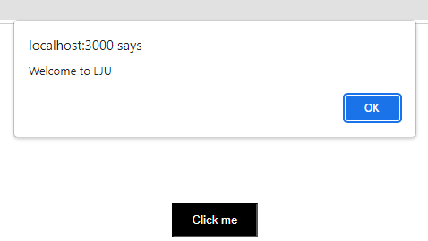

- Example of onchange event
Write react js script to display values in console while changing it in text box.

Event2.jsx
import React from 'react';
function Event2() {
function handleChange(event) {
console.log (event.target.value);
}
return (
<input type=”text” name="firstName" onChange={handleChange} />
);
}
export default Event2;
App.jsx
import Event2 from "./Event2"
function App() {
return (
<div>
<Event2/>
</div>
);
}
export default App;

Output:
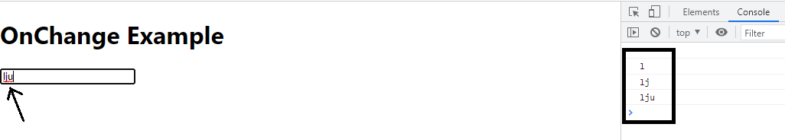

event.target gives the element that triggered the event.
So, event.target.value retrieves the value of that element (an input field, in above example).

- Example of DoubleClick event
Write react js script to display alert box with text “welcome to lju” only on double click.
Event3.jsx
import React from 'react';
function Event3() {
const mystyle = {
color : "white",
backgroundColor : "#000000",
padding: "10px 20px",
margin:"30px"
};

const doubleClickHandler = (event) => {
alert("Welcome to LJU");
}
return (
<>
<button style={mystyle} onDoubleClick = {doubleClickHandler}>Double Click here</button>
</>
);
}
export default Event3;
App.jsx
import Event3 from "./Event3"
function App() {
return (
<div>
<Event3/>
</div>
);
}
export default App;
Output:
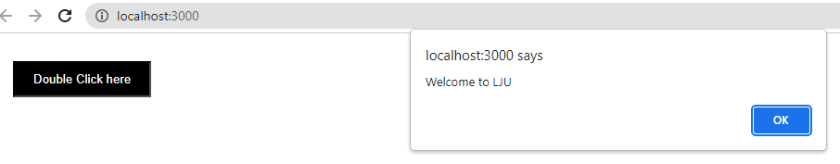
- Example of onSubmit event
Write react js script to display alert box with text “You clicked submit.” only on submitting form.
Event4.jsx
function Event4() {
function handleSubmit (e) {
e.preventDefault ();
alert (' You clicked submit.');
}

return (
<form onSubmit = {handleSubmit}>
<button type="submit">Submit</button>
</form>
);
}export default Event4;
App.jsx
import Event3 from "./Event4"
function App() {
return (
<div>
<Event4/>
</div>
);
}
export default App;

Example to understand concept of function calling with ()
function App() {
const handleclick = () => {
alert('Welcome to LJU');
};
return (
<div>
<center>
<button onClick={handleclick()}>Click me</button>
</center>
</div>
);
}
export default App;

Output:
On page load, the alert pops up: "Welcome to LJU"
But when you click the button, nothing happens because the onClick handler is now undefined.
Explaination:

The function handleclick() is being called immediately inside onClick={handleclick()} instead of passing a reference.
So, as soon as the component renders, it will call the function handleclick(). An alert box appears with the message “Welcome to LJU”

React Routing
- React does not include page routing by default.
- To perform routing in React applications, we use React Router.
- React Router is the most popular library used for routing in React applications.
- It helps create Single Page Applications (SPA) where pages change without reloading the browser.

Install React Router
Run the following command in terminal:
npm install react-router-dom

Purpose of React Router
React Router is used to:
- navigate between pages
- create SPA (Single Page Application)
- change URL dynamically
- render components based on URL path

Important Components in React Router
1. BrowserRouter
BrowserRouter enables routing in React application and keeps UI synchronized with URL.
It acts as the parent component for routing.
Syntax
<BrowserRouter>
App Components
</BrowserRouter>
2. Routes
<Routes> is used to group multiple <Route> components.
React checks routes and renders the best matching route.
Syntax
<Routes>
<Route path="/" element={<Home />} />
</Routes>
3. Route
<Route> is used to define which component should render for a specific URL path.
Syntax
<Route path="/home" element={<Home />} />

4. Link
<Link> is used for navigation between pages without refreshing the browser.
It works similar to HTML anchor tag.
Syntax
<Link to="/home">Home</Link>

Important Note
Do Not Use
<a href="/home">Home</a>
because it reloads the page.
Use
<Link to="/home">Home</Link>
to maintain SPA behavior.

Routing Flow
URL changes
↓
React Router checks matching path
↓
Matching component renders
Example
Create a React application using functional components and React Router DOM.
Requirements
- Create routes for:
  - Home
  - Shop
  - Contact
  - 404 NoPage
- Implement navigation using Link.
- Display:
  - Home page on Home route
  - Shop page on Shop route
  - Contact Detail on Contact route
  - 404 Page not Found for invalid URL
- Create My.js file which contains Links for Home, Shop and Product page. Also, add functionality of page routing.Finally call My.js in App.js.
App.js
My.js
(Include all component and routing)
Home.js
(Home page content)
Shop.js
(Shop page content)
Contact.js
(Contact page content)
Nopage.js
(Page not found content)
App.css

App.jsx
import './App.css';
import My from "./routing/My.jsx";

function App() {
return (
<div>
<My/>
</div>
);
}
export default App;
(Below all files are inside routing folder in src folder.)
routing/My.jsx
import React from 'react';
import {BrowserRouter as Router,Route,Routes,Link} from "react-router-dom";
import Home from './Home';
import Contact from './Contact'
import Shop from './Shop'
import Nopage from './Nopage';
function My() {
return (
<div>
<Router>
<div className='main-route'>
<ul>
<li><Link to="/">Home</Link></li>
<li><Link to="/shop">Shop</Link></li>
<li><Link to="/contact">Contact</Link></li>
</ul>
</div>
<Routes>
<Route path="/" element={<Home/>}/>
<Route path="/contact" element={<Contact/>}/>
<Route path="/shop" element={<Shop/>}/>
<Route path="*" element={<Nopage/>}/>
</Routes>
</Router>

</div>
);
}
export default My
Setting the path to * will act as a catch all undefined URLs and display 404 error page.

routing/Home.jsx
import React from 'react'
function Home(){
return (
<div>
<h1>Home page</h1>
</div>
)
}
export default Home

routing/Shop.jsx
import React from 'react'
function Shop(){
return (
<div>
<h1>Shop page</h1>
</div>
)
}
export default Shop

routing/Contact.jsx
import React from 'react'
function Contact() {
return (
<div>
<h1>Contact Detail</h1>
</div>
)
}
export default Contact

routing/Nopage.jsx
import React from 'react'
function Nopage() {
return (
<div>
<h1>404 Page not Found</h1>

</div>
)
}
export default Nopage

App.css (It is Not compulsory to add this file in this example. Added css for the reference only)
.main-route ul {
list-style-type: none;
margin: 0;
padding: 0;
overflow: hidden;
background-color: #000;
margin-bottom: 50px;
}
.main-route li {
float: left;
}
.main-route li a {
display: block;
color: white;
text-align: center;
padding: 20px;
text-decoration: none;
}
.main-route h1{ color: red; text-align: center;

Miscellaneous Examples
Example
Create a React app to perform the following tasks using functional components:
Implement the following components in your React application:
- Main.js to set up the router and define the routes.
- Home.js for the Home page.
- Product.js for the Product page.
- Create a React Router:
  - Include two routes: Home and Product. Implement navigation between these routes.
- Create the following routes and components:
  - When a user clicks on the Home page link, it should navigate to the Home page and display "Welcome to LJU" within an <h1> heading with blue color. Also, include link to product page.
  - A Product page that displays three products' information (name, price, and image) using props. When a user clicks on the Product page link, it should navigate to the Product page and display three products' information name, price and product image using props.

Main.jsx
import {BrowserRouter as Router,Route,Routes,Link} from "react-router-dom";
import Home from './home';
import Product from './product'
import Nopage from './nopage';
import img1 from "./img1.jpg"
import img2 from "./img2.jpg"
import img3 from "./img3.png"
function Main() {
const products=[{name:"p1",price:20000, pic:img1},{name:"p2",price:14000, pic:img2},{name:"p3",price:40000, pic:img3}]
return (
<div>
<Router>
<ul>
<li><Link to="/">Home</Link></li>
<li><Link to="/product">Product</Link></li>
</ul>
<Routes>
<Route path="/" element={<Home/>}/>
<Route path="/product" element={<Product info={products}/>}/>
<Route path="*" element={<Nopage/>}/>
</Routes>
</Router>

</div>
);
}
export default Main
home.jsx
function Home(){
return (
<div>
<h1 style={{color:"blue"}}>Home page</h1>
<a href="/product">Product</a>
</div>
)
}
export default Home
nopage.jsx
function Nopage() {
return (
<div>
<h1>404 Page not Found</h1>
</div>
)
}
export default Nopage
product.jsx
const Product = (Props)=>{
return(
<div>
{
Props.info.map((p)=>{
return(
<div>
<img src={p.pic} alt="product" height={200} width={200}/>
<h1>{p.name}</h1>
<h1>{p.price}</h1>
</div>
)
})
}
</div>
);
}
export default Product;

Example
Create a component to perform the tasks as described below:
1. Add a text field and a submit button.
- While changing the value in the text field, display it below the form.
- Display this text field value in an alert box upon submitting it.
2. Add a button to perform click and double-click event tasks.
- On click event, display message in h3 tag “You clicked once”.
- On double-click event, display message in h3 tag “You clicked twice”.
- Message should be displayed below the button.

function Map1() {
const arr=[1,2,3,4,5];
function handleSubmit (e) {
e.preventDefault ();
alert (document.getElementById('uname').value);
}
function handleclick(){
document.getElementById('test1').innerHTML = “You clicked once”
}
function handledoubleclick(){
document.getElementById('test1').innerHTML = “You clicked twice”
}
function handleChange(event) {
document.getElementById('test').innerHTML =event.target.value;
}
return (
<div>
<form onSubmit = {handleSubmit}>
<input type="text" id="uname" onChange={handleChange}></input>
<input type="submit"/>
</form>

<h1 id="test">On change event</h1>

<button style={{backgroundColor:'black',padding:"20px",color:"white"}} onClick={handleclick} onDoubleClick={handledoubleclick}>Click</button>
<h1 id="test1">Click/DoubleClick event</h1>
</div>
)
}

export default Map1

Reference

public/ vs src/assets/
public/ | src/assets/
Static files | Component-related files
Direct URL access | Imported into React components
No Vite optimization | Optimized by Vite
Good for favicon, PDFs | Good for images/icons used in components

Example

Store in public/
public/logo.png
Use directly:
<img src="/logo.png" />

Store in src/assets/
src/assets/logo.png
Import before use:
import logo from './assets/logo.png'
<img src={logo} />

